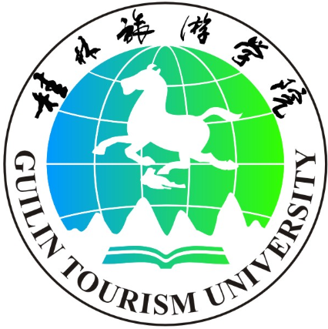
桂林旅游学院留学生申请表

Photo
GUILIN TOURISM UNIVERSITY
APPLICATION FORM

1. Which program are you applying for?
Program Title:
Start Date: Month Year |  |  |  |  |  |  |  |  | □Full-time |  |  | □Part-time
Duration of Study: _______Month(s) ________Year(s)
2. Your personal details
Gender: □Male □Female |  |  |  |  |  | Marital status: □Single □Married □Others
Family Name/ Surname: : (BLOCK CAPITALS)
Forename(s):
Date of Birth:(eg dd.mm.yy) |  |  |  |  |  |  |  |  | Religion:
Passport Number: |  |  |  |  |  |  |  |  | Nationality:
Home Tel: ( inc. Country/Area Code)
Mobile No.: ( inc. Country/Area Code)
Home Address：

Postcode: |  |  |  |  |  |  | E-mail：
3. Language Level (Please ensure enclose certified copied of certificates).
Level of Chinese( HSK ):
Date of Test: Month: Year： |  |  |  |  |  |  |  |  | Result：
Level of English (IELTS, TOEFL etc) :
Date of Test: Month: Year： |  |  |  |  |  |  |  |  | Result：
4. Details of Your Education
From | to |  | Name & Address of School |  |  |  |  | Diploma/Degree |  |  | Type of Course
5. Details of Your Employment
From |  | to |  | Name & Address of Company |  |  |  |  |  | Position
6. Checklist
□ Completed and signed application
□ Academic qualifications – copies of transcripts / certificates
□ Photocopy of certificate in English language level
□ Photocopy of your passport
7. How did you hear about us?
□Agent □Exhibition □Family of friends □Internet
□Other(please specify)
8. Declaration
I confirm that, to the best of my knowledge, the information given in this form is correct and complete.

Signature of Applicant: Date:

School of International Education and Exchange，Guilin Tourism University,
No.26 Liangfeng Road, Guilin, 541006, China
Tel: +86-773-3690101 Fax: +86-773-3690218
Email: istudy@gltu.cn Website: http://www.gltu.cn

